**ToyCraft Tales: Tableau's Vision into Toy Manufacturer Data**

1. **INTRODUCTION**

**Project Overview:**

The project titled "ToyCraft Tales: Tableau’s Vision into Toy Manufacturer Data" explores the historical patterns and evolving dynamics of the U.S. toy manufacturing industry between 2005 and 2016. Using Tableau as the primary visualization and analytical tool, this project transforms raw CSV data into interactive dashboards, unveiling insights into state-wise manufacturer distribution, declining industry trends, and potential regional market opportunities. The visual narratives are structured to empower stakeholders—such as analysts, strategists, and policymakers—with the ability to detect actionable insights, simulate demand patterns, and build resilient growth strategies in a data-driven manner.

**Purpose**

The core purpose of this project is to highlight the steady decline in U.S. toy manufacturers over a 12-year period and to help decision-makers visualize the industry’s historical trends and regional shifts. By developing and showcasing interactive Tableau dashboards, the project aims to:

* Enable stakeholders to identify top-performing and underrepresented states in toy production
* Simulate seasonal or demographic market behaviors using calculated visual patterns
* Provide a tool for strategic planning, regional investments, and product-line development
* Illustrate the power of Tableau as a medium for transforming complex data into intuitive visual storytelling

1. **IDEATION PHASE**

**Problem Statement:**

The U.S. toy manufacturing industry experienced a consistent decline in the number of manufacturers between 2005 and 2016. Despite the availability of historical data, stakeholders—including analysts, strategists, and policymakers—face significant challenges in identifying patterns, regional disparities, and the underlying causes behind this decline. Traditional static reports fail to provide the interactive exploration needed to derive actionable insights. There is a clear need for a dynamic, visually-driven solution that transforms raw data into meaningful narratives to support strategic decision-making, detect untapped opportunities, and stimulate informed investment in the toy sector.

| **Prompt** | **Guiding Question** | **Customized Response** |
| --- | --- | --- |
| **I am** | Describe the customer with 3–4 key characteristics – who are they? | A data-driven business analyst or strategist in the U.S. toy industry, seeking to uncover regional trends and historical performance of manufacturers. |
| **I'm trying to** | List their outcome or “job” they care about – what are they trying to achieve? | Make informed, strategic decisions by visualizing historical manufacturing data and predicting growth opportunities using Tableau dashboards. |
| **but** | Describe what problems or barriers stand in the way – what bothers them most? | Raw data is complex and lacks immediate insights; no easy visibility into trends, state-wise comparisons, or seasonal variations. |
| **because** | Enter the “root cause” of why the problem or barrier exists – what needs to be solved? | Traditional reports are static and fragmented, and there’s limited tooling to translate complex data into intuitive, interactive insights. |
| **which makes me feel** | Describe the emotions from the customer’s point of view – how does it impact them emotionally? | Frustrated, uncertain, and under pressure to deliver decisions quickly without enough clarity or confidence from the data alone. |

**Example:**

| **Problem Statement (PS)** | **I am (Customer)** | **I'm trying to** | **But** | **Because** | **Which makes me feel** |
| --- | --- | --- | --- | --- | --- |
| **PS-1:** U.S. toy manufacturing has been declining steadily from 2005 to 2016, and businesses lack clarity on trends. | A toy industry strategist, data analyst, or planner in the U.S. | Make informed decisions about where and how to invest or scale manufacturing. | The available data is raw, fragmented, and lacks interactive insights. | Traditional reports don't help simulate scenarios or visualize regional shifts effectively. | Frustrated, under pressure, and limited by poor visibility into market behavior. |
| **PS-2:** There’s a need for interactive tools that reveal regional manufacturing trends and market seasonality shifts. | A policymaker, consultant, or stakeholder reviewing industrial performance and economic development. | Develop strategies that support local manufacturing and understand toy industry behavior across states. | Current tools lack the granularity, storytelling, and simulation needed to identify insights. | There's no unified dashboard that combines spatial, time-series, and category-level analysis. | Confused, hesitant to invest, and in need of intuitive data guidance. |

**Empathy map:**

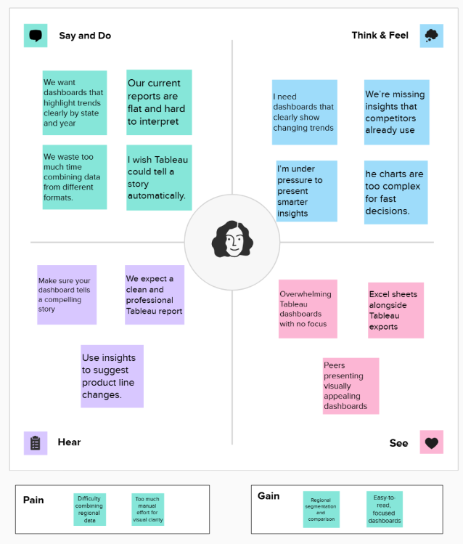

**Brainstorming:**

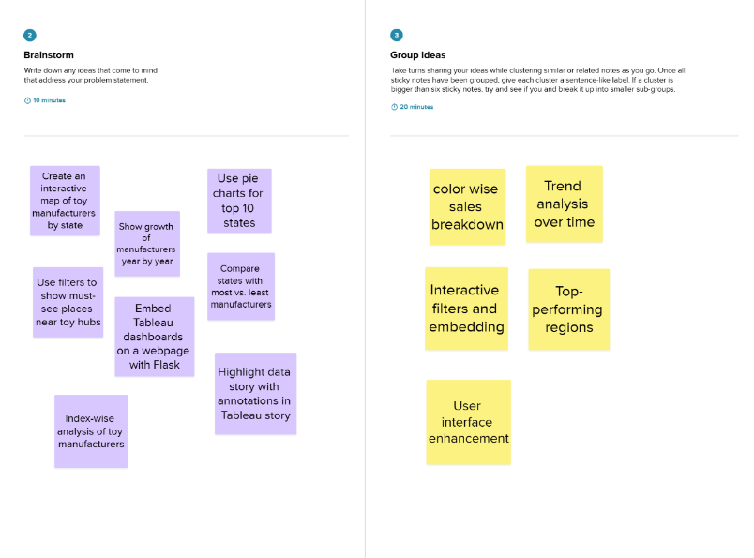

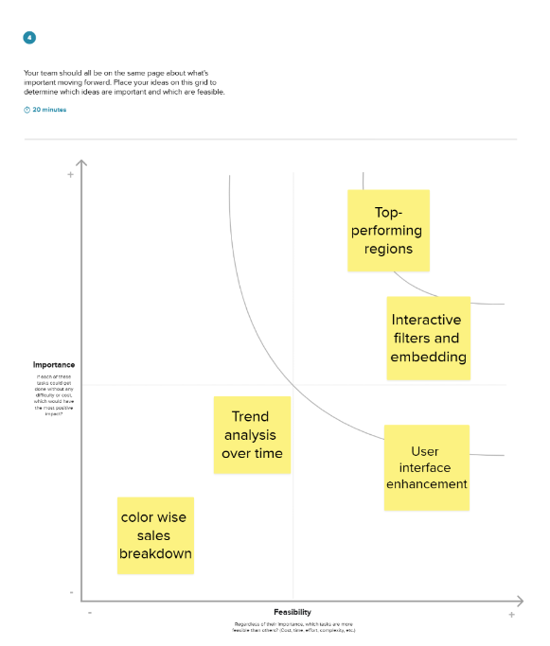

1. **REQUIREMENT ANALYSIS**

**Customer Journey map**

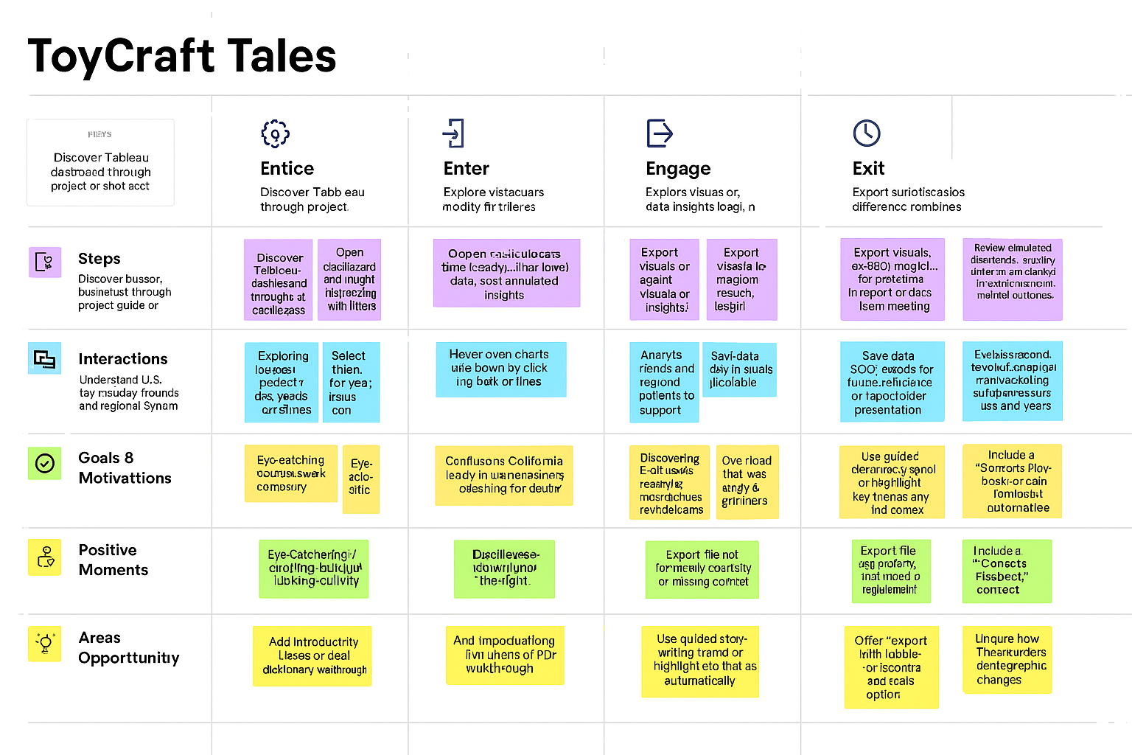

**Solution Requirement**

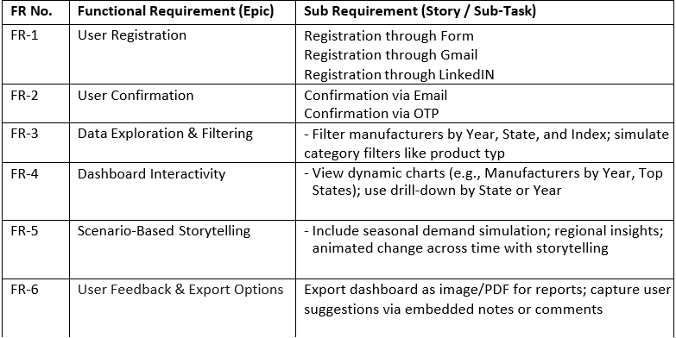

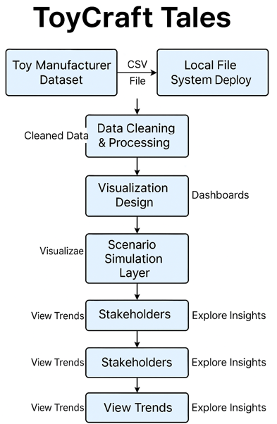**Data Flow Diagram:**

**Technology Stack:**

|  |  |  |
| --- | --- | --- |
| **Component** | **Tool / Technology** | **Purpose** |
| **Data Source Layer** | food_coded.csv | Raw dataset containing students’ dietary behaviors,  preferences, and lifestyle indicators |
| **Data Storage** | SQL Workbench / CSV File | Centralized storage for cleaned and filtered datasets |
| **Data Processing** | Python (pandas, NumPy) | Cleaning, filtering, recoding variables, and transforming data for analysis |
| **Data Filtering** | SQL Queries | Custom filters based on GPA, calorie intake, gender, diet status, etc. |
| **Statistical Modeling** | R Programming (optional) | Advanced statistical analysis (e.g., ANOVA, regression) |
| **Visualization Engine** | Tableau Desktop / Tableau Public | Create interactive dashboards to visualize trends and behavioral patterns |
| **Web Framework** | Flask | Serve visualizations via a lightweight Python web app |
| **Embedding Tool** | Tableau IFrame Integration | Embed dashboards into the Flask application |
| **Version Control** | GitHub | Code repository, versioning, and collaboration |

|  |  |  |
| --- | --- | --- |
| **S.No.** | **Parameter** | **Description** |
|  | Problem Statement (Problem to be solved) | The U.S. toy manufacturing industry has experienced a consistent decline in the number of manufacturers between 2005 and 2016. Stakeholders lack clear insights into regional dynamics, seasonal demands, and evolving consumer preferences—hindering strategic decision-making. |
|  | Idea / Solution description | "ToyCraft Tales" is a data visualization initiative built using Tableau that transforms raw manufacturing data into interactive dashboards. It uncovers market trends, regional performance, and simulated customer preferences to guide decision-making and foster industry revival. |
|  | Novelty / Uniqueness | The project goes beyond static reporting by blending historical trends with interactive storytelling. By simulating seasonal and demographic insights from limited data, it introduces new ways to explore market demand, enabling dynamic, location-aware strategy development. |
|  | Social Impact / Customer Satisfaction | The dashboard equips manufacturers, planners, and policymakers with the tools to identify underserved regions, adapt to seasonal preferences, and align offerings with customer needs—ultimately driving customer satisfaction and encouraging local economic development. |
|  | Business Model (Revenue Model) | The solution supports subscription-based access for manufacturers, consulting firms, and retail analysts. Additional revenue streams include custom dashboard development, regional data packages, and training services on demand forecasting. |
|  | Scalability of the Solution | The model can scale horizontally across geographies (e.g., international toy markets) and vertically across product categories (e.g., educational toys, tech-integrated play). It can also integrate real-time retail or e-commerce data for future expansion. |

1. **PROJECT DESIGN**

**Proposed Solution**

**Problem Solution Fit:** 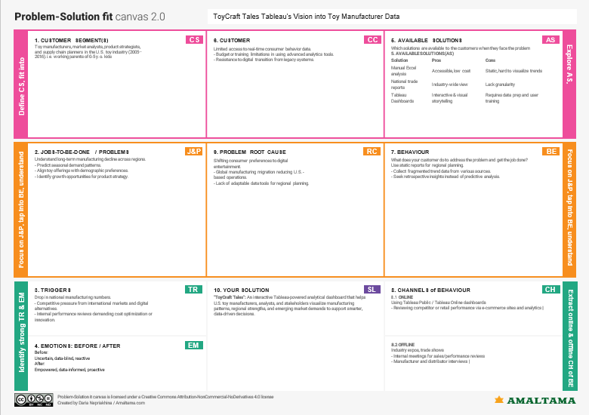

**Solution Architecture**

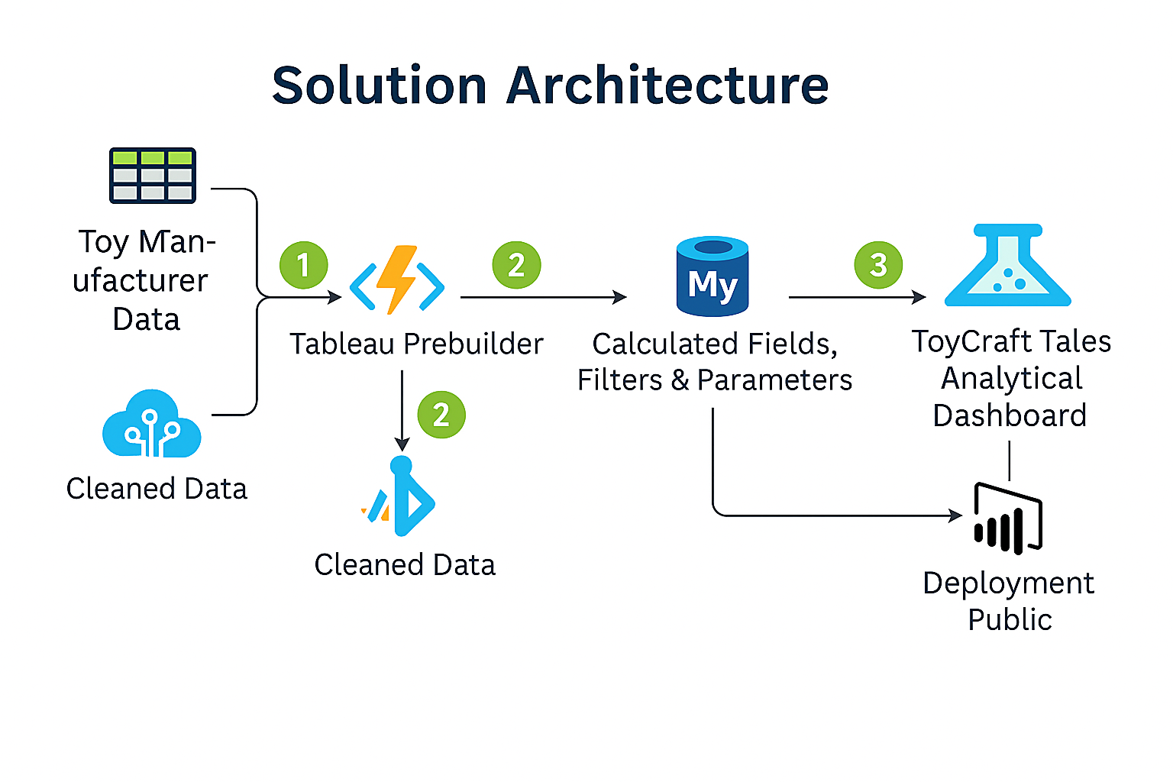

1. **PROJECT PLANNING & SCHEDULING**

**Project Planning**

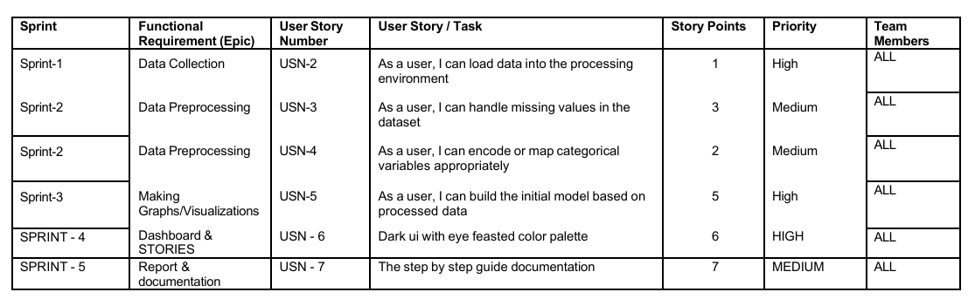

1. **FUNCTIONAL AND PERFORMANCE TESTING**

**Performance Testing**

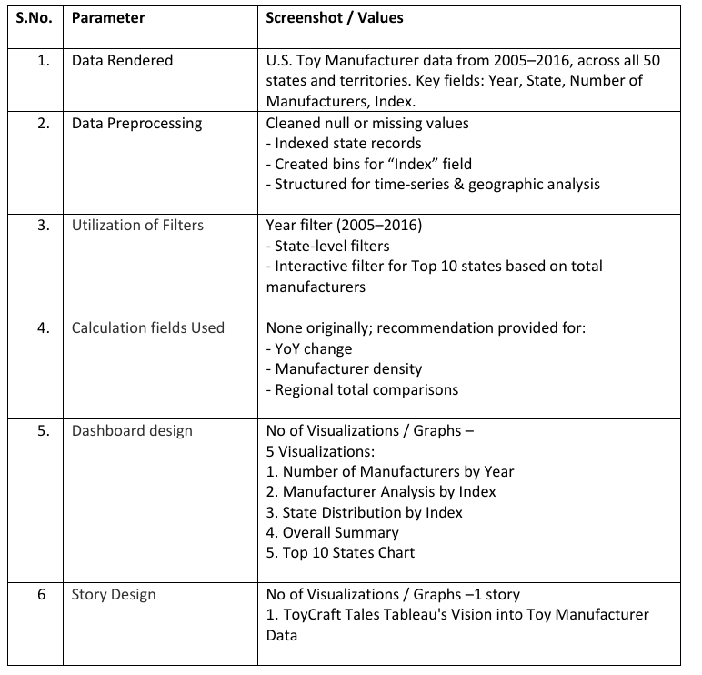

1. **RESULTS**

**Output Screenshots**

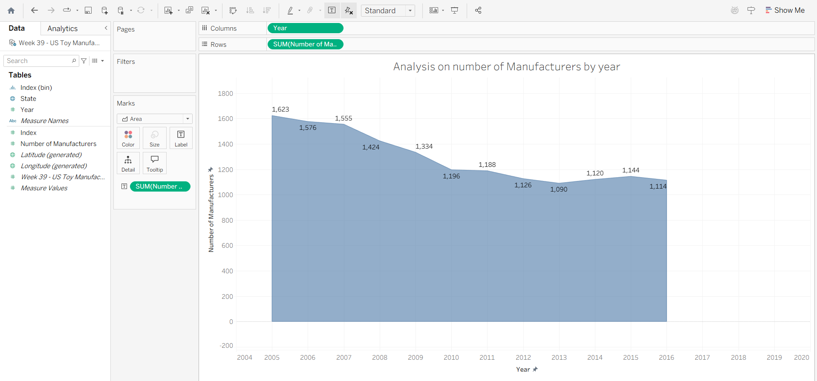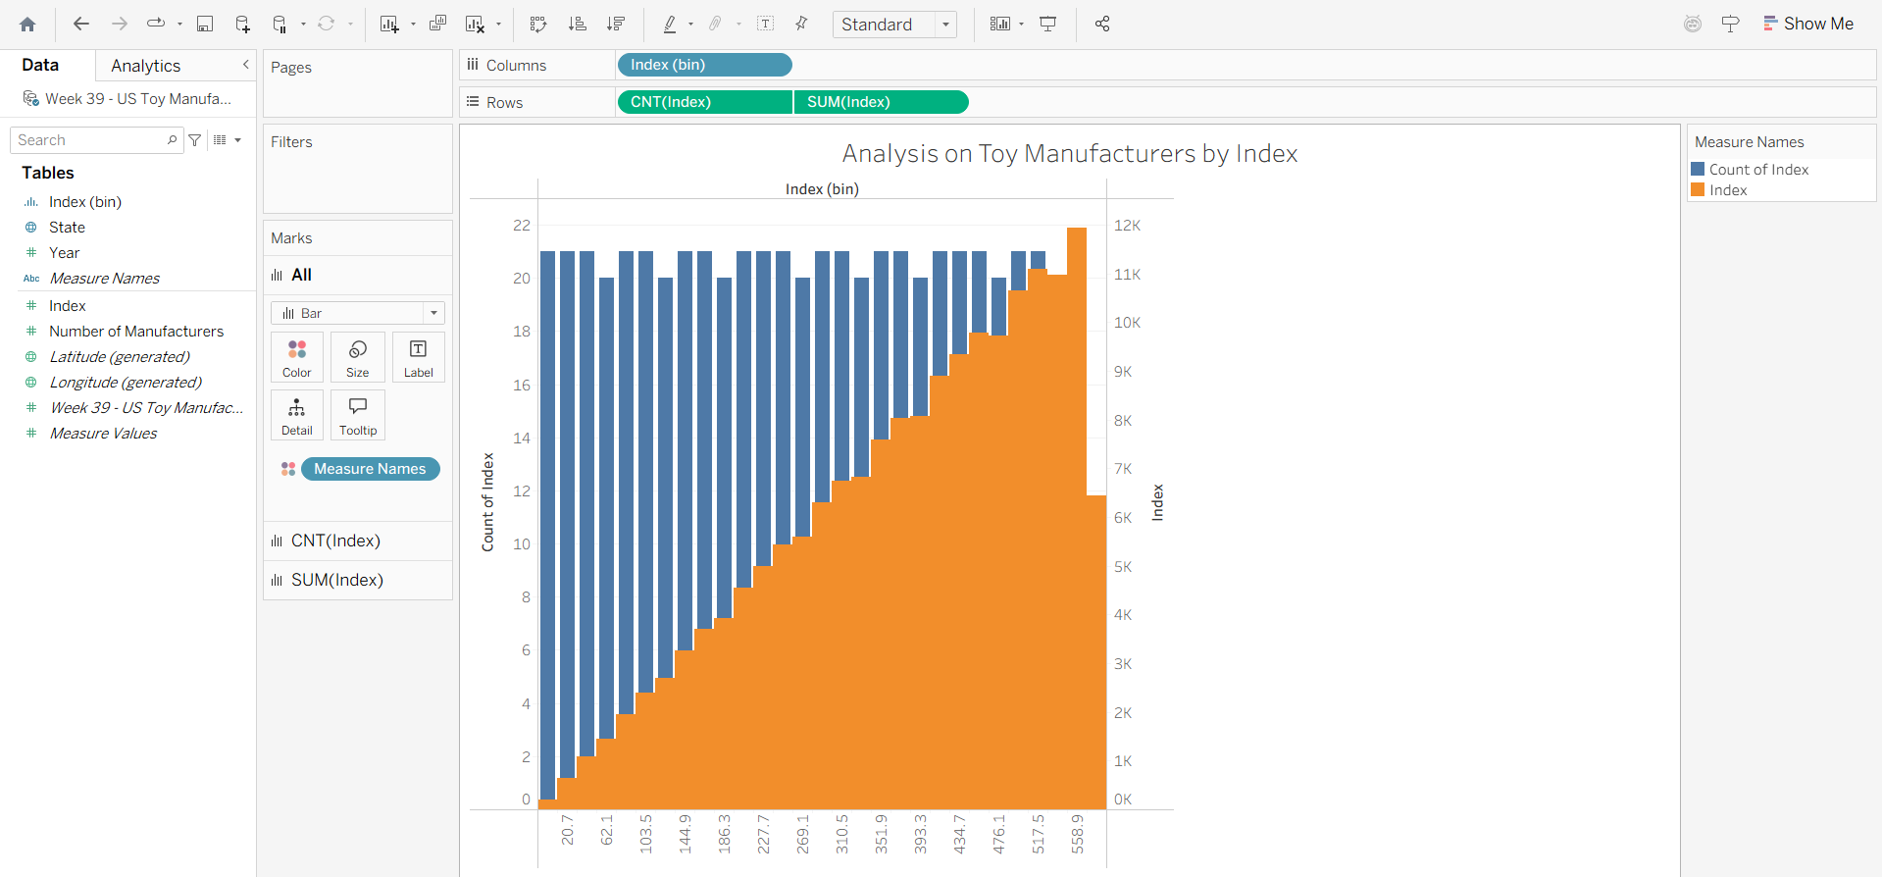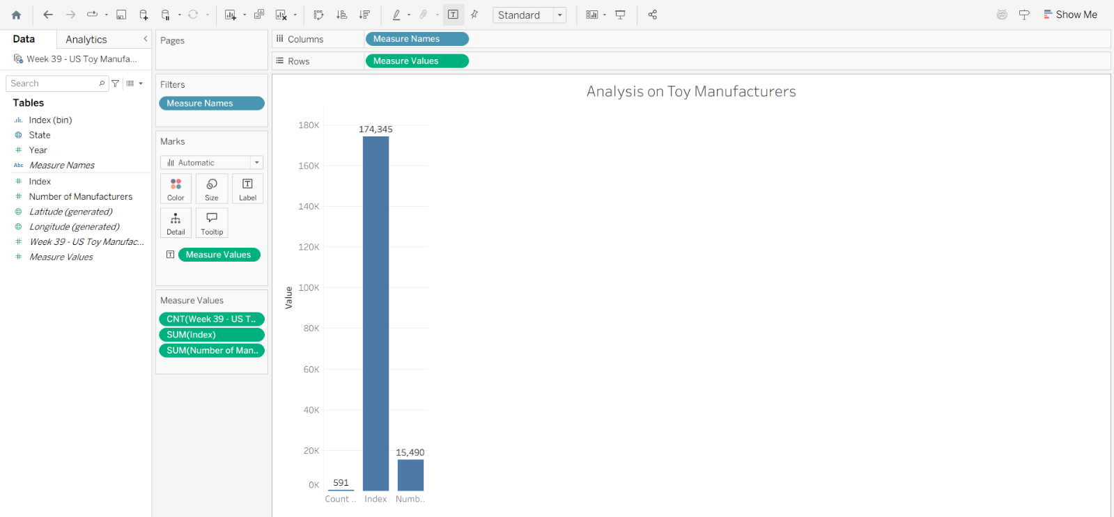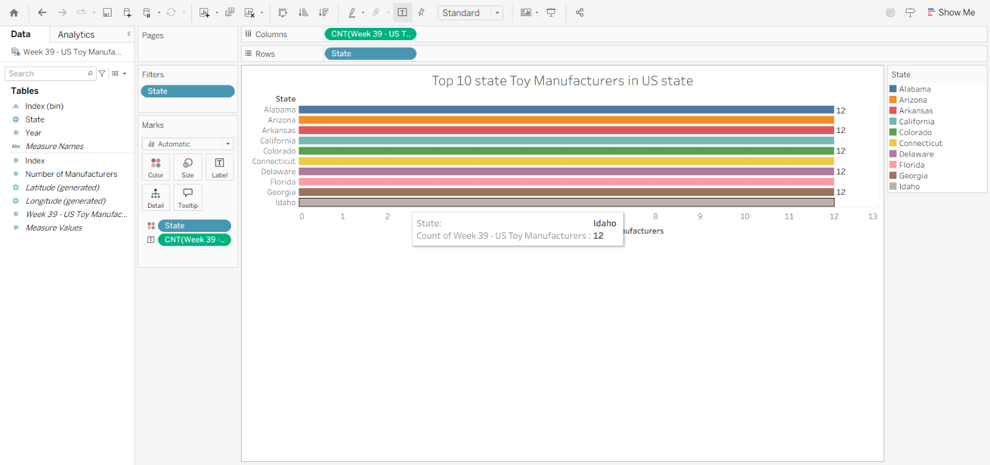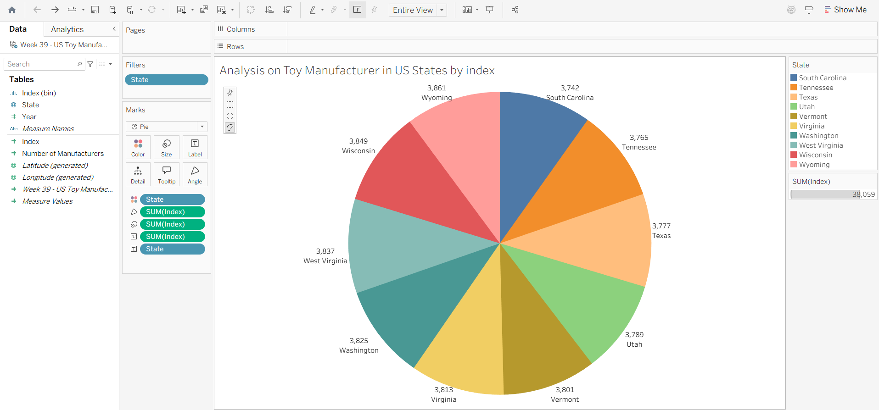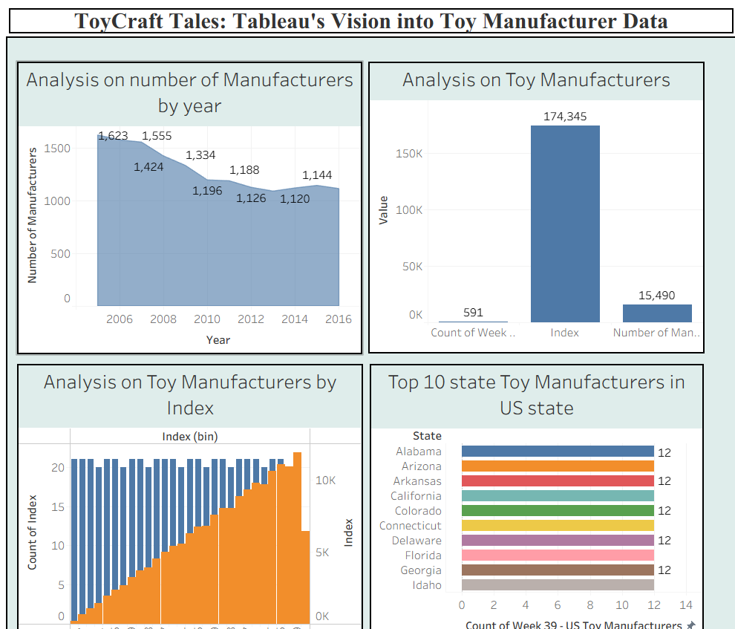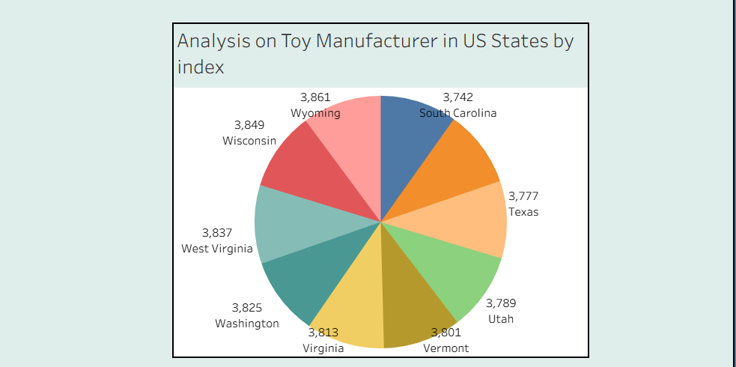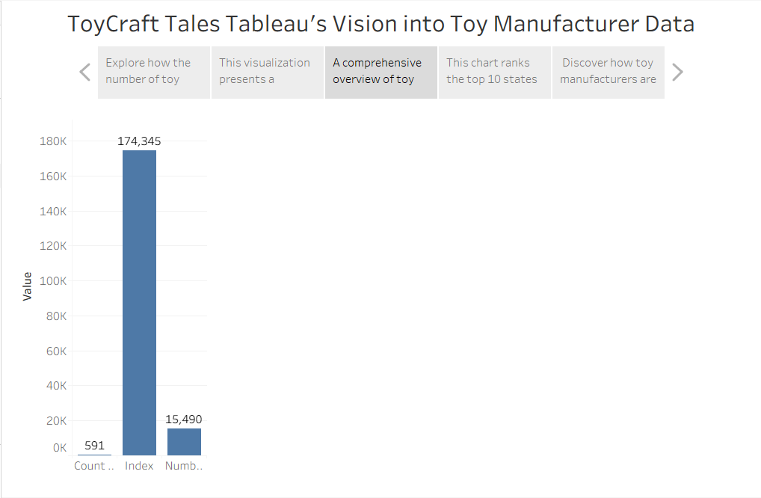

1. **ADVANTAGES & DISADVANTAGES**

| **Advantages** | **Disadvantages** |
| --- | --- |
| **Offers interactive, visually intuitive insights for non-technical users.** | **Tableau’s advanced interactivity requires some initial learning curve.** |
| **Enables easy comparison of time trends and state-level performance.** | **Limited predictive capabilities without additional forecasting tools.** |
| **Facilitates scenario simulations using filters and calculated fields.** | **Historical data limits the ability to reflect recent industry trends post-2016.** |
| **Encourages data-driven decisions in toy manufacturing and policy planning.** | **Requires access to Tableau Desktop/Public for building or customizing views.** |

1. **CONCLUSION**

The ToyCraft Tales project successfully transformed complex, historical manufacturing data into a powerful decision-making tool through interactive Tableau dashboards. Stakeholders can now explore year-over-year trends, identify top-performing regions, and simulate market behavior to uncover hidden opportunities. The solution bridges the gap between raw data and actionable insights, enabling the U.S. toy industry to better understand its past and strategize its future.

1. **FUTURE SCOPE**

• **Expand Dataset** to include global toy markets or newer data post-2016 for more relevant insights.

• **Integrate AI/ML** to forecast future manufacturing trends and detect anomalies.

• **Enhance Accessibility** with mobile-optimized dashboard deployment or Power BI integration.

• **Add Consumer Segmentation** to align manufacturing strategies with buyer demographics.

• **Incorporate Real-Time Feeds** from industry APIs, trade reports, or economic indicators.

1. **APPENDIX**

**Source Code**

**APP.PY**

from flask import *

app=flask(__name__)

@app.route("/")

def home():

    return render_template("index.html")

if __name__=="__main__":

    app.run (debug = True, port = 2323)

**INDEX.HTML**

<!DOCTYPE html>

<html lang="en">

<head>

  <meta charset="UTF-8" />

  <meta name="viewport" content="width=device-width, initial-scale=1.0"/>

  <title>ToyCraft Tales</title>

  <style>

    * {

      margin: 0;

      padding: 0;

      box-sizing: border-box;

      font-family: 'Segoe UI', sans-serif;

    }

    html, body {

      height: 100%;

      background: #f8f9ff;

    }

  nav {

      background-color: #fff;

      padding: 1rem 2rem;

      display: flex;

      justify-content: space-between;

      align-items: center;

      box-shadow: 0 0 10px rgba(0,0,0,0.05);

      position: fixed;

      width: 100%;

      top: 0;

      z-index: 1000;

    }

    nav h1 {

      font-size: 24px;

      color: #1d4ed8;

    }

    nav ul {

      list-style: none;

      display: flex;

      gap: 2rem;

    }

    nav ul li {

      font-size: 1rem;

    }

    nav ul li a {

      text-decoration: none;

      color: #1d4ed8;

      font-weight: 500;

    }

    section {

      min-height: 100vh;

      display: flex;

      align-items: center;

      justify-content: center;

    }

    .hero {

      padding: 4rem 3rem 0;

      background: linear-gradient(to bottom, #eef4ff 0%, #ffffff 100%);

      flex-direction: row;

    }

    .hero-text {

      flex: 1;

      z-index: 2;

      display: flex;

      flex-direction: column;

      justify-content: center;

      height: 100%;

    }

    .hero-text h2 {

      font-size: 4vw;

      background: linear-gradient(90deg, #1e3a8a, #3b82f6);

      -webkit-background-clip: text;

      -webkit-text-fill-color: transparent;

      margin-bottom: 1rem;

    }

    .hero img {

      flex: 1;

      max-width: 500px;

      border-radius: 20px;

      z-index: 2;

    }

    .btn {

      margin-top: 1.5rem;

      padding: 0.8rem 1.5rem;

      background-color: #3b82f6;

      color: #fff;

      border: none;

      border-radius: 8px;

      font-size: 1rem;

      cursor: pointer;

      text-decoration: none;

      box-shadow: 0 5px 15px rgba(59,130,246,0.3);

      width: fit-content;

    }

    .wave {

      display: block;

      margin-top: -1px;

      position: relative;

      z-index: 1;

    }

    .about {

      padding: 4rem 3rem;

      flex-direction: row;

      background-color: transparent;

    }

    .about-container {

      display: flex;

      background: #ffffff;

      padding: 2rem;

      border-radius: 20px;

      box-shadow: 0 5px 20px rgba(0, 0, 0, 0.1);

      max-width: 1200px;

      width: 100%;

      gap: 2rem;

      align-items: center;

      justify-content: center;

    }

    .about-text {

      flex: 1;

      display: flex;

      flex-direction: column;

      justify-content: center;

      height: 100%;

    }

    .about-text h3 {

      font-size: 1.2rem;

      color: #3b82f6;

      margin-bottom: 0.5rem;

    }

    .about-text p {

      font-size: clamp(1rem, 2vw, 1.5rem);

      line-height: 1.6;

      color: #1f2937;

      max-width: 95%;

    }

    .about img {

      flex: 1;

      max-width: 400px;

      border-radius: 15px;

    }

    .dashboard, .story {

      padding: 3rem;

      flex-direction: column;

      background-color: #eef4ff;

    }

    .dashboard h2, .story h2 {

      text-align: center;

      color: #1e40af;

      margin-bottom: 1.5rem;

    }

    .tableauPlaceholder {

      display: block;

      margin: 0 auto;

      width: 90%;

      height: 500px;

      border: none;

      border-radius: 12px;

      box-shadow: 0 4px 15px rgba(0,0,0,0.1);

    }

    footer {

      background-color: #1e3a8a;

      color: #fff;

      text-align: center;

      padding: 1.5rem;

      margin-top: 2rem;

    }

    @media (max-width: 768px) {

      .hero, .about-container {

        flex-direction: column;

        text-align: center;

      }

      .hero img, .about img {

        margin-top: 2rem;

        width: 100%;

      }

    }

  </style>

</head>

<body>

  <nav>

    <h1>ToyCraft Tales</h1>

    <ul>

      <li><a href="#hero">Home</a></li>

      <li><a href="#about">About</a></li>

      <li><a href="#dashboard">Dashboard</a></li>

      <li><a href="#story">Story</a></li>

    </ul>

  </nav>

  <section class="hero" id="hero">

    <div class="hero-text">

      <h2>ToyCraft Tales: Tableau's Vision into Toy Manufacturer Data</h2>

      <a href="#dashboard" class="btn">Get Started →</a>

    </div>

    <img src="ai.jpg" alt="Factory Image" />

  </section>

  <section class="about" id="about">

    <div class="about-container">

      <div class="about-text">

        <h3>Who We Are</h3>

        <p>

          Toy manufacturing involves the process of designing, producing, and assembling toys for children and, in some cases, adults. The industry is diverse, encompassing a wide range of products, from traditional toys like dolls and action figures to modern electronic toys and games.

        </p>

      </div>

      <img src="toy.jpeg" alt="Mickey Toys Image" />

    </div>

  </section>

  <svg class="wave" viewBox="0 0 1440 320"><path fill="#eef4ff" fill-opacity="1" d="M0,64L48,85.3C96,107,192,149,288,160C384,171,480,149,576,138.7C672,128,768,128,864,122.7C960,117,1056,107,1152,117.3C1248,128,1344,160,1392,176L1440,192L1440,320L1392,320C1344,320,1248,320,1152,320C1056,320,960,320,864,320C768,320,672,320,576,320C480,320,384,320,288,320C192,320,96,320,48,320L0,320Z"></path></svg>

  <section class="dashboard" id="dashboard">

    <h2>Interactive Dashboard</h2>

<div class='tableauPlaceholder' id='viz1750945667055' style='position: relative'><noscript><a href='#'><img alt='ToyCraft Tales: Tableau&#39;s Vision into Toy Manufacturer Data ' src='https:&#47;&#47;public.tableau.com&#47;static&#47;images&#47;To&#47;ToyCraft&#47;ToyCraftTalesTableausVisionintoToyManufacturerData&#47;1_rss.png' style='border: none' /></a></noscript><object class='tableauViz'  style='display:none;'><param name='host_url' value='https%3A%2F%2Fpublic.tableau.com%2F' /> <param name='embed_code_version' value='3' /> <param name='site_root' value='' /><param name='name' value='ToyCraft&#47;ToyCraftTalesTableausVisionintoToyManufacturerData' /><param name='tabs' value='no' /><param name='toolbar' value='yes' /><param name='static_image' value='https:&#47;&#47;public.tableau.com&#47;static&#47;images&#47;To&#47;ToyCraft&#47;ToyCraftTalesTableausVisionintoToyManufacturerData&#47;1.png' /> <param name='animate_transition' value='yes' /><param name='display_static_image' value='yes' /><param name='display_spinner' value='yes' /><param name='display_overlay' value='yes' /><param name='display_count' value='yes' /><param name='language' value='en-US' /></object></div>                <script type='text/javascript'>                    var divElement = document.getElementById('viz1750945667055');                    var vizElement = divElement.getElementsByTagName('object')[0];                    if ( divElement.offsetWidth > 800 ) { vizElement.style.width='1000px';vizElement.style.height='1427px';} else if ( divElement.offsetWidth > 500 ) { vizElement.style.width='1000px';vizElement.style.height='1427px';} else { vizElement.style.width='100%';vizElement.style.height='1577px';}                     var scriptElement = document.createElement('script');                    scriptElement.src = 'https://public.tableau.com/javascripts/api/viz_v1.js';                    vizElement.parentNode.insertBefore(scriptElement, vizElement);                </script>  </section>

  <section class="story" id="story">

    <h2>Data Storytelling</h2>

<div class='tableauPlaceholder' id='viz1750945263124' style='position: relative'><noscript><a href='#'><img alt='ToyCraft Tales Tableau&#39;s Vision into Toy Manufacturer Data ' src='https:&#47;&#47;public.tableau.com&#47;static&#47;images&#47;To&#47;ToyCraft&#47;ToyCraftTalesTableausVisionintoToyManufacturerData_1&#47;1_rss.png' style='border: none' /></a></noscript><object class='tableauViz'  style='display:none;'><param name='host_url' value='https%3A%2F%2Fpublic.tableau.com%2F' /> <param name='embed_code_version' value='3' /> <param name='site_root' value='' /><param name='name' value='ToyCraft&#47;ToyCraftTalesTableausVisionintoToyManufacturerData_1' /><param name='tabs' value='no' /><param name='toolbar' value='yes' /><param name='static_image' value='https:&#47;&#47;public.tableau.com&#47;static&#47;images&#47;To&#47;ToyCraft&#47;ToyCraftTalesTableausVisionintoToyManufacturerData_1&#47;1.png' /> <param name='animate_transition' value='yes' /><param name='display_static_image' value='yes' /><param name='display_spinner' value='yes' /><param name='display_overlay' value='yes' /><param name='display_count' value='yes' /><param name='language' value='en-US' /></object></div>                <script type='text/javascript'>                    var divElement = document.getElementById('viz1750945263124');                    var vizElement = divElement.getElementsByTagName('object')[0];                    vizElement.style.width='1016px';vizElement.style.height='691px';                    var scriptElement = document.createElement('script');                    scriptElement.src = 'https://public.tableau.com/javascripts/api/viz_v1.js';                    vizElement.parentNode.insertBefore(scriptElement, vizElement);                </script>  </section>

  <footer>

    &copy; 2025 ToyCraft Tales. All rights reserved.

  </footer>

</body>

</html>

**Dataset Link:**

[https://www.kaggle.com/datasets](https://www.kaggle.com/datasets/thedevastator/toy-manufacturers-in-us-states?select=Week+39+-+US+Toy+Manufacturers+-+2005+to+2016.hyper)

**GitHub & Project Demo Link**

<https://github.com/K-Naveenkumar1/Toy-Craft>

[https://k-naveenkumar1.github.io/Toycraft](https://k-naveenkumar1.github.io/Toycraft/)/